**A**

**PROJECT REPORT**

**ON**

**REMOTE HEALTH MONITORING SYSTEM WITH ANALYTICS DASHBOARD**

SUBMITTED BY

**PROF. RUCHA R. SHRIRAM**

UNDER THE GUIDANCE OF

**SMART INTERNZ**

AS A PART OF,

**IBM GURUCOOL FDP**

INDEX

|  |  |  |  |  |  |  |
| --- | --- | --- | --- | --- | --- | --- |
| **1** |  | **INTRODUCTION** | |  |  |  |
|  |  | 1.1 Overview | |  |  |  |
|  |  | 1.2 Purpose | |  |  |  |
| **2** |  | **LITERATURE SURVEY** | |  |  |  |
|  |  | 2.1 Existing problem | | |  |  |
|  |  | 2.2 Proposed solution | | |  |  |
| **3** |  | **THEORITICAL ANALYSIS** | |  |  |  |
|  |  | 3.1 Block diagram | |  |  |  |
|  |  | 3.2 Hardware / Software designing | | |  |  |
| **4** |  | **EXPERIMENTAL INVESTIGATIONS** | | |  |  |
| **5** |  | **FLOWCHART** | |  |  |  |
| **6** |  | **RESULT** |  |  |  |  |
| **7** |  | **ADVANTAGES, DISADVANTAGES AND APPLICATIONS** | | |  |  |
| **8** |  | **CONCLUSION AND FUTURE SCOPE** | |  |  |  |
|  |  | **REFERENCES** | |  |  |  |

# CHAPTER 1

**INTRODUCTION**

**1.1 OVERVIEW:**

The Internet of things is the inter-connection of devices, apps, sensors and network connectivity that enhances these entities to gather and exchange data. The distinguishing characteristic of Internet of Things in the healthcare system is the constant monitoring a patient through checking various parameters and also infers a good result from the history of such constant monitoring. Many such devices equipped with medical sensors are present in the ICUs now-a-days. There could be instances where the doctor couldn’t be alerted in time when there is an emergency, despite of 24 hours of monitoring. Also there might be hurdles in sharing the data and information with the specialist doctors and the concerned family members and relatives. The technology that enhances these features is already available but is not accessible and affordable by most of the people in developing countries such as India. Hence these solutions to these problems can be just a simple extension to the current devices which don’t have thesefacilities.

The world population is increasing tremendously. The cities accommodating more population face astounding pressure of urban living. Even though the medical resources and facilities in cities are expanded daily, still the suffice level is not attained. The massive pressure towards the management of healthcare in cities has triggered the advancement in technologies to come out with the proper solutions to the booming problems. With the increased rate of medically challenged people, remote healthcare has become a part of our life. In recent years, it is observed that the increased interest in wearable sensors and such devices are available in market for cheaper rate for personal healthcare and activity awareness. Researchers considered implementation of such advanced devices for the medical applications for data recording, management and also to continuously monitor the patient’shealth.

The Internet of Things offers a rising technology to attain the next level of health services. It assures for the affordable, low-cost, reliable and handy devices to be carried or embedded with the patients, so that to enable seamless networking between the patients, medical devices and physicians. The sensors will record signals in a continuous manner, they are then correlated with the essential physiological parameters and communicated over the wireless network. The resulting data is stored, processed and analyzed with the existing health records. Using the available data records and decision support systems, the physician can do a better prognosis so that to suggest early treatment. Even when the doctor is not available, this analysis enables the today’s machines to predict the health issues. Not only prediction, machines can also be able to come out with the medicines from the systematic study of the medicinal databases. The progressive technology will have a transformative impact in every human’s life and health monitoring; it will remarkably cut down the healthcare expenses and a step ahead in the accuracy of disease predictions. In this project, an idea is presented of a service model in technological and economic views for the comfort of patients and also the open challenges in implementing IOT in real world medicalfield.

**1.2 PURPOSE:**

The purpose of the project can be summarized as following:

* To obtain the real-time medical information about a patient via IBM IOT Platform.
* Processing and classification of information gathered about thehealth parameters using IBM Machine learning service.
* To view the health parameters and status of prediction using IBM Node-Red application in real time.
* To provide Internet of Things based healthcare solutions at anytime and anywhere.

# 

# CHAPTER 2

# LITERATURE SURVEY

**2.1 EXISTING PROBLEM:**

This section provides a literature review of the existing Remote Health Monitoring System with Analytics Dashboard as follows:

K. Santhiya, B. Kamalakannam, S. Muthu Gowtham, A. Pandian, R. Ram Pradeep, [1] “Human Body Health Monitoring System in the Fusion of IoT & Cloud Computing” International Journal of Engineering Research in Computer Science & Engineering (IJERCSE) March 2018. The paper that proposed the work of this project is to develop a system that can be implemented with real-time wireless monitoring systems which are designed and implemented through IOT and are able to record and transmit bio-signals of any distinct. The aim of this project is to provide a medical monitoring such as the heart beat and body temperature for the individual at any time and any place. Here sensors are used to sense the parameters of the human body, the sensed outputs from the sensors are then sent to the arduino and as per the conditions programmed the control will take the necessary actions such as transmitting the data through a IOT to cloud. The esp will act as a interface between arduino and Wi-Fi, which used to transfer the sensored data to the cloud. The values are transmitted in the digital form to the arduino and it can be send to the cloud as the same. This will be mainly used for old patients because the major cause of death of old patients will be by due to careless monitor of old patients.

C. Senthamilarasi, J. Jansi Rani, B. Vidhya, H. Aritha, [2] “A Smart Patient Health Monitoring System Using IoT” International Journal of Pure and Applied Mathematics 2018. The paper proposed the work of this project is the vital parameters such as temperature, EEG and heart beat readings which are monitored using Arduino Uno. These sensors signals are send to Arduino Uno via amplifier circuit and signal conditioning unit (SCU), because the signals level are low (gain), so amplifier circuit is used to gain up the signals and transmit the signals to the Arduino Uno. Here patients body temperature , EEG and heart rate is measured using respective sensors and it can be monitored in the screen of computer using Arduino Uno connected to a cloud database system as well as monitored anywhere in the world using internet source. The proposed method of patient monitoring system monitors patient’s health parameters using Arduino Uno. After connecting internet to the Arduino Uno, it is connected to cloud database system which actsas a server. Then the server automatically sends data to the receiver system. Hence, it enables continuous monitoring of the patient’s health parameters by the doctor. Any abrupt increase or decrease in these parameter values can be detected at the earliest and hence necessary medications can be implemented by the doctor immediately.

Shafaque Nasaruddin Soparkar, Dr. Lochan Jolly, [3] “Improved Medical Healthcare System Based on IoT” International Journal of Innovative Research in Science, Engineering & Technology 2017. The key motive of the designed system is to continuous monitoring of the patients over internet. In this system LPC2148 Microcontroller collects the data from the sensors and sends the data through Wi- Fi Protocol. The Protected data sent can be accessed anytime by the doctors by typing the corresponding unique IP address in any of the Internet Browser at the end user device (ex: Laptop, Desktop, Tablet, Mobile phone).The GSM Modem is connected to Microcontroller which will provide information to doctor/caretaker when the heart rate is above or below the threshold value and when the temperature is above or below the threshold value. During this time the buzzer/alarm turns on and alerts the caretaker. LCD is connected to microcontroller to display the transaction process and other healthcare data. And the user interface html webpage will automatically refresh for every time hence patient health status is continuously sent to the doctor. Hence continuous monitoring of patientsdata.

M. Vengateshwaran, S. Shubhlakshmi, E.Sivasankari, R. thamaraiselvi, [4] “A Modern Approach For Smart Healthcare Monitoring System Remotely Using IoT and Raspberry Pi” IOSR Journal of Engineering 2017. This proposed system is the remotely monitoring healthcare system by using IOT and Raspberry pi successfully by means of providing notification (SMS or email) and alarm generation. Through this we can reduce the possibility of a human error and also through this we can monitor the health condition of patient from home and as from hospital. In future we formed the special kind of mobile application which will sent the notification faster when compared to the present system. Furthermore, it provides a better security like fingerprint scans and password to avoid accessing the medical reports by unauthorized person. In addition to that in future, if any critical situation happens to the patient, automatically a call will be connected to the patient’s family and consultant doctorimmediately.

Mehmet Tastan, [5] “IoT Based Wearable Smart Health Monitoring System” Celal Bayar University Journal Of Science 2018.This proposed system is for individuals with heart disease, the Heart Rate (HR), Heart Rate Variability (HRV) and Body Temperature (BT) values are considered vital signs that must be measured regularly. In this study, an android-based application is developed that can monitor HR, HRV and CT parameters for cardiovascular patients who should be under constant observation. The measuring system, which consists of wearable sensors, constantly measures patient signs. Then send the measured signals to android interface via wireless connection. If the predetermined critical values for the patient are exceeded, the HR, HRV, CT values and also the real time location of patient is sent both to family members and doctor as e-mail and twitter notification. The wearable measurement system allows patients to be mobile in their own social environment, allowing them to live their lives inconfidence.

Rishabh Jain [6] “IoT Based Patient Monitoring System Using ESP8266 And Arduino”. This system is an IoT based Health Monitoring System which records the patient heart beat rate and body temperature and also send an email/SMS alert whenever those readings goes beyond critical values. Pulse rate and body temperature readings are recorded over Thing Speak and Google sheets so that patient health can be monitored from anywhere in the world over internet. A panic will also be attached so that patient can press it on emergency to send email/sms to their relatives.

**2.2 PROPOSED SOLUTION:**

This system, Remote Health Monitoring System with Analytics Dashboard implemented using IBM services. This system is designed to continuously monitor the vital parameters such as body temperature, systolic, diastolic and pulse. The information is stored on a IBM cloud and can be displayed through IBM Node-Red application in real time. The main objective of this system is to update the data online which can be seen by the doctors for any abnormality and also predict the health status depending on the health parameters using IBM Machine Learning service.

# 

# CHAPTER 3

# THEORETICAL ANALYSIS

**3.1 BLOCK DIAGRAM:**

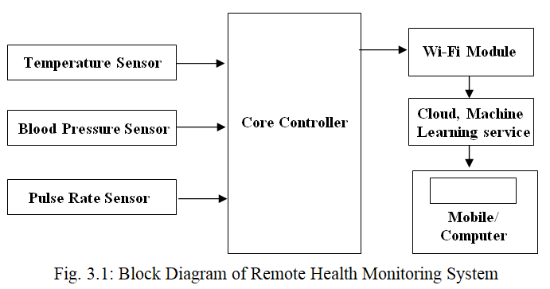As seen in fig. 3.1, there are sensors to measure body temperature, blood pressure and pulse. These sensors are connected to the core controller which processes the received health parameters. After data processing, these parameters are sent to an IOT platform where, analysis can be carried out for prediction of health status based on the health parameters. Hence, the health parameters and status is visible on the mobile or a computer in real time due to IOT services.

# 3.2 HARDWARE / SOFTWARE DESIGNING:

For implementation of this system, IBM Cloud services are used. As IBM Cloud is an online platform, the system is implemented at software level. The services used for implementing this system are: IBM IOT Platform, IBM Machine Learning service, IBM Node-Red Application and IBM Cloudant DB. IBM Watson™ IoT Platform is a fully managed, cloud-hosted service that makes it simple to derive value from Internet of Things (IoT) devices. One has to simply register and connect their device, be it a sensor, a gateway, or something else, to Watson IoT Platform and start sending data securely up to the cloud using the open, lightweight MQTT messaging protocol. One can set up and manage their devices using their online dashboard or IBM’s secure APIs, so that their apps can access and use live and historical data.

Using IBM Watson Machine Learning, one can build analytical models and neural networks, trained with our own data that we can deploy for use in applications. Watson Machine Learning provides a full range of tools and services so one can build, train, and deploy Machine Learning models. Choose from tools that fully automate the training process for rapid prototyping to tools that gives complete control to create a model that matches ones needs. IBM Node-Red application service provides facilities to deploy, and scale server-side JavaScript® apps with ease on IBM Cloud Foundry. The IBM SDK for Node.js™ provides enhanced performance, security, and serviceability

|  |
| --- |
|  |

|  |
| --- |
|  |

.

**CHAPTER 4**

**EXPERIMENTAL INVESTIGATIONS**

Experimental investigations are as depicted below:

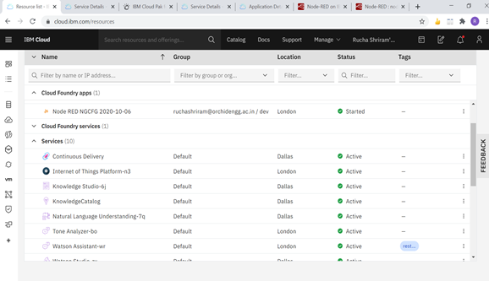Fig. 4.1 IBM Cloud Dashboard

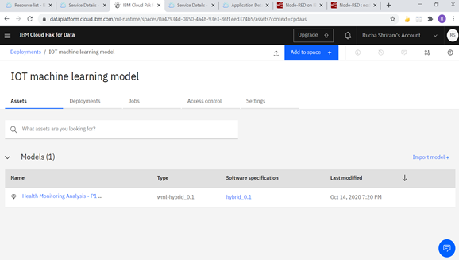Fig. 4.2 IBM Machine Learning Model

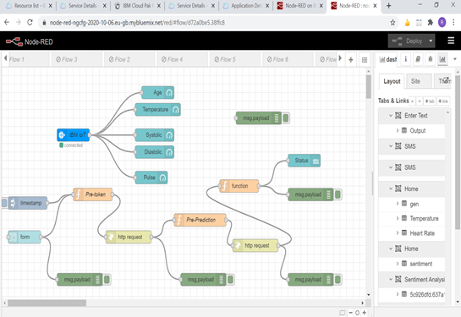Fig. 4.3 Project Flow in IBM Node-Red Application

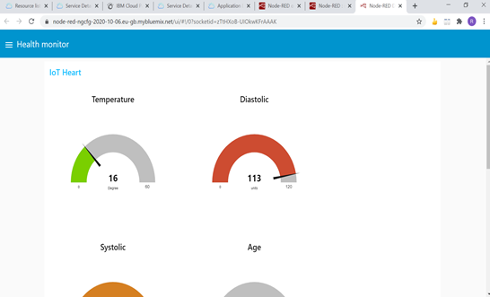

Fig. 4.4 IBM Node-Red Application UI for displaying Health Parameters

**CHAPTER 5**

**FLOWCHART**

Flowchart for Remote Health Monitoring System with Analytics Dashboard is as follows:

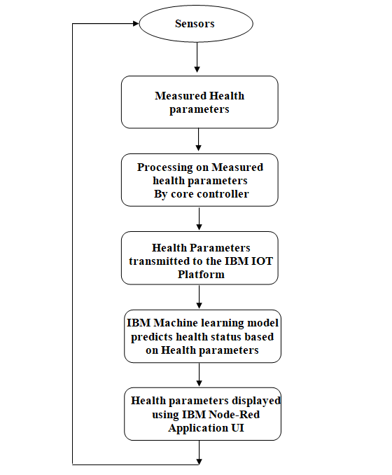Fig. 5.1 IBM Node-Red Application UI displaying Health Parameters

**CHAPTER 6**

**RESULT**

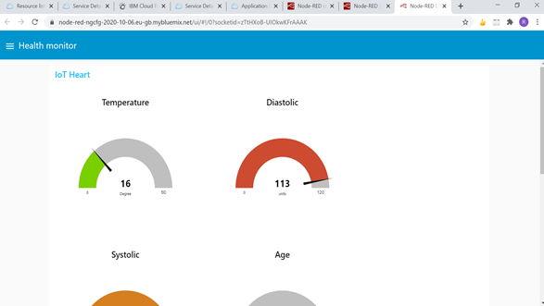Fig. 6.1 IBM Node-Red Application UI displaying Health Parameters

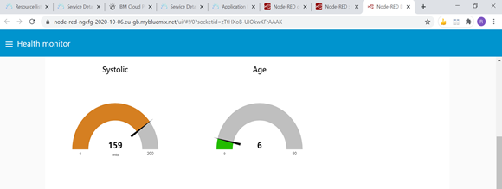Fig. 6.2I BM Node-Red Application UI displaying Health Parameters

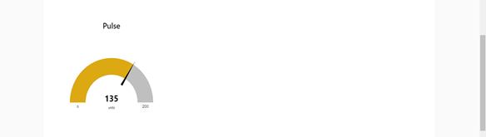 Fig. 6.3 IBM Node-Red Application UI displaying Health Parameters

|  |
| --- |
|  |

|  |
| --- |
|  |

**CHAPTER 7**

**ADVANTAGES, DISADVANTAGES AND APPLICATIONS**

**7.1ADVANTAGES**

* Waiting time of a patient in the reception is reduced.
* Hospital visits for normal routine check ups are minimized.
* Patient health parameters data is stored over cloud so it easy for the doctor to access it anytime.
* Health status is predicted by IBM Machine Learning model.

**7.2DISADVANTAGES**

* Needs continuous Internet supply

**7.3 APPLICATIONS:**

* Hospital management system.
* Health parameters monitoring in real time by any individual.

**CHAPTER 8**

**CONCLUSION AND FUTURE SCOPE**

**8.1 CONCLUSION**

The proposed system is designed for the Remote Health Monitoring with Analytics Dashboard. It measures vital health parameters such as Body Temperature, Systolic, Diastolic and Pulse using various sensors. The core controller processes these sensor values and sends it to the IBM IOT platform which is visible using the IBM Node-Red Application. A doctor at any remote location can login and check the patient’s health parameters. This minimizes normal routine checkups visits of a patient by visiting a doctor in case of minor uneasiness.

**8.2 FUTURE SCOPE**

* A wearable device can be implemented in hardware to monitor health status.
* Real time health status can be provided to the doctor about patients.

**REFERENCES**

[1] www.cloud.ibm.com

[2] K. Santhiya, B. Kamalakannam, S. Muthu Gowtham, A. Pandian, R. Ram Pradeep, “Human Body Health Monitoring System in the Fusion of IoT & Cloud Computing” International Journal of Engineering Research in Computer Science & Engineering (IJERCSE) March 2018.

[3] C. Senthamilarasi, J. Jansi Rani, B. Vidhya, H. Aritha, “A Smart Patient Health Monitoring System Using IoT” International Journal of Pure and Applied Mathematics 2018.

[4] Shafaque Nasaruddin Soparkar, Dr. Lochan Jolly “Improved Medical Healthcare System Based on IoT” International Journal of Innovative Research in Science, Engineering & Technology 2017.

[5] M. Vengateshwaran, S. Shubhlakshmi, E.Sivasankari, R. thamaraiselvi, “A Modern Approach For Smart Healthcare Monitoring System Remotely Using IoT and Raspberry Pi” IOSR Journal of Engineering 2017.

[6] Mehmet Tastan, “IoT Based Wearable Smart Health Monitoring System” Celal Bayar University Journal Of Science 2018.

[7] Rishabh Jain “IoT Based Patient Monitoring System Using ESP8266 And Arduino”.